Question 1: (4.0 Point)
At running the GUI looks like below:
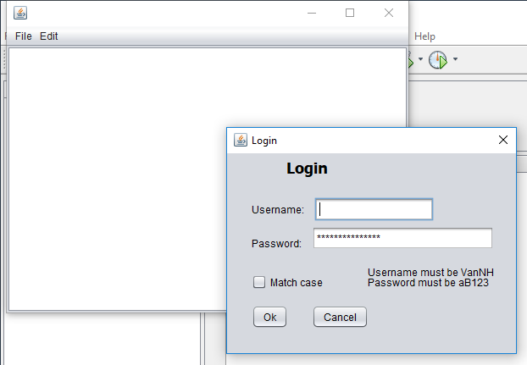

When you enter data and click “Ok”, the program check whether name = “VanNH” and password = “aB123” If that, then the following message will displayed in the text are:

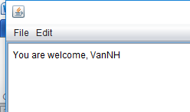
. .
If you enter differently, then the following window appears:
